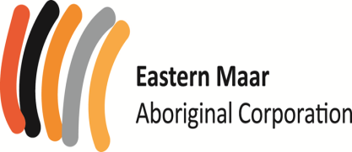
PO Box 546
Warrnambool VIC 3280

Eastern Maar Aboriginal Corporation
Negotiation Team;
Cultural Landscapes Subcommittee; and Economic Development Subcommittee Information Pack

OUTLINE ON EASTERN MAAR’s APPROACH TOWARD SECURING OUTCOMES UNDER THE TRADITIONAL OWNER SETTLEMENT ACT AND NATIVE TITLE.
Eastern Maar is currently pursuing two distinct paths towards the goal of achieving settlement of native title for the extent of our traditional territory/lands.
The two paths are distinct but connected and include:
Native Title consent determination:
Where the Australian legal system through the federal court process formally recognises our rights and interests in our lands and waters through our traditional laws and customs.
The Native Title recognises rights over land and waters, according to traditional laws and customs (s.223 NTA). While the native title rights recognised will be specific to each determination, they may include such rights as:
- Maintain and protect sites
- Use the land for hunting or ceremony
- Camp and live on the land
- Share in money from any development on the land
- Have a say in the management or development of the land
Traditional Owner Settlement Act (TOSA) Negotiations:
Occuring alongside the Eastern Maar Native title claim through the Federal Court process, EMAC is also negotiating with the State of Victoria under the Traditional Owner Settlement Act 2010.
In Victoria, the Traditional Owner Settlement Act 2010 provides an alternative system for resolving native title claims and provides for an out-of-court settlement of native title and delivery of land justice.
Potential Benefits of a Recognition and Settlement Agreement
A Recognition and Settlement Agreement under the Traditional Owner Settlement Act is an attractive alternative to pursuing a native title determination as:
- It is a streamlined, expedited and cost effective approach to settling native title claims by negotiation
- It includes new outcomes to increase the proportion of Aboriginal people with access to their traditional lands and to increase economic and social opportunities in Victoria
- It contributes to reconciliation in Victoria through building stronger partnerships with Aboriginal Victorians, resolving long-standing land grievances, and strengthening communities and cultural identity
Potential Components of a Settlement Agreement
A Recognition and Settlement Agreement is entered into by the Attorney-General and Traditional Owners under the Traditional Owner Settlement Act can include the following:
- Land Agreement – formalises the handing back of parks and reserves of significance to the Traditional Owner group to be jointly managed with the State
- Land Use Activity Agreement – provides a simplified regime to guide consultation and negotiation with Traditional Owners for activities that have a substantial impact on Traditional Owner rights in public land within the agreement area
- Natural Resource Agreement – provides for the access to, and sustainable use of, natural resources and Traditional Owner participation
OUR REFRESHED NEGOTIATION STRUCTURE
In 2018 the Eastern Maar Full Group authorised for the EMAC Board of Directors to represent all native title rights holders in Negotiations with the State Government under the Traditional Owner Settlement Act. Since that time the EMAC Board of Directors have been negotiating in good faith with the Victorian State Government per the TOSA regime. At the most recent AGM held in November 2019 new EMAC Board members were appointed to the Board requiring the composition of the Negotiating team to be changed to reflect the new Board of Director makeup.
In our aim to put our best foot forward in strongly negotiating the best outcome for our people under the State Government TOSA regime and pushing for the best outcomes to secure Native Title recognition, EMAC have decided to refresh the negotiation structure. For clarity and transparency there were also non Board members appointed to the negotiation team in 2018 alongside the Board of Directors and it was decided that in keeping with the intent of a refreshed approach EMAC would renew an expressions of interest process calling for members of the EMAC membership to sit on the following new structures, consisting of:
- A point Negotiation Team whose role will be to negotiate directly with the State Government for Traditional Owner settlement.
- Sitting underneath the Point negotiation team will be a Cultural Landscapes Subcommittee titled Cultural Landscapes (Ngootjoon Meerreeng) subcommittee. The establishment of the Cultural Landscapes (Ngootjoon Meerreeng) subcommittee serves two distinct but complimentary purposes; they include:
  - Purpose one will be to provide Cultural Heritage specific expertise by undertaking background research and contributing to the strategic framing of Cultural Heritage specific negotiation points and asks for use by the authorised negotiation team to strongly pitch those points to the State of Victoria in EMAC’s Traditional Owner Settlement Act negotiations.
  - Purpose two will be to protect and promote Maar values within the Eastern Maar cultural landscape. These values include, but are not limited to, tangible and intangible cultural heritage, native title and cultural obligations to look after Country. Specifically, the committee will assist EMAC Cultural Landscapes Staff as a quality assurance mechanism in:
    - Developing EMAC’s cultural heritage management principles and guidelines
    - Providing advice and recommendations in response to Cultural Heritage Management Plans, cultural heritage permits and other formal requests when referred by EMAC’s GM of Cultural Landscapes
The Cultural Landscapes (Ngootjoon Meerreeng) subcommittee will be a best practice model that also contributes to increased participation opportunities for Eastern Maar Citizens in decision-making processes that effect their cultural heritage, future acts, and landscape management objectives.
- Sitting alongside the Cultural Landscapes (Ngootjoon Meerreeng) subcommittee and underneath the negotiation team will be an Economic Development Subcommittee. The purpose of the Economic Development subcommittee is to provide economic development specific expertise by undertaking background research and contributing to the strategic framing of economic and commercial specific negotiation points and asks for use by the authorised negotiation team to strongly pitch those points to the State of Victoria in EMAC’s Traditional Owner Settlement Act negotiations.

Visually the three (Negotiation Team and two subcommittees) are set up as follows:
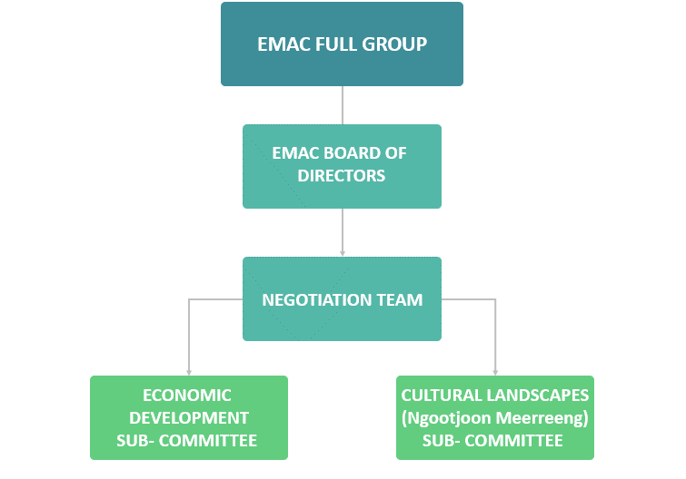
Figure 1. EMAC Committees diagram

ABOUT THESE OPPORTUNITIES
EMAC is putting a call out to our members for expressions of interest to join either the:
- Negotiation Team
- Cultural Landscapes (Ngootjoon Meerreeng) Subcommittee
- Economic Development Subcommittee
Each of the two subcommittees’ purpose, role, membership and operating practices, including member remuneration for participation, are outlined in the Terms of References attached at appendix 1 and 2.
Negotiation Team and subcommittee membership selection process
Selection criteria have been developed to evaluate all applications in a fair and transparent way. The selection criteria are as follows:
- Extent of an individual’s skills, experience and knowledge on Eastern Maars vision
- Description of skills, experience and knowledge provided relating to the specified membership application
- Areas identified for diversity of skills, experience and knowledge within the Team and subcommittees
- Commitment to participate in the team and subcommittees
Short listed applicants may be interviewed by a small panel.
Negotiation Team and subcommittee appointment process and timeline is outlined in table 1.
Table 1: Negotiation Team timeframes
25 May – 12 June 2020 | Applications open for Eastern Maar Negotiation Team and subcommittees
15 June – 19 June 2020 | Assessment of applications by EMAC Directors
22 June – 26 June 2020 | Notification of Negotiation and Subcommittee appointments and acceptance of appointment confirmation.

Eastern Maar Negotiation Team and Subcommittees Application Form

- Contact details
Fields marked (*) are mandatory
* Name:
* Street Address:
* Town: |  |  |  | * Postcode: |  | * State:
*Phone:
Email:

- *Please select which you are applying for
☐ | Negotiation Team | ☐ | Cultural Landscapes (Ngootjoon Meerreeng) subcommittee
☐ | Economic Development Subcommittee

- * Skills, experience and knowledge
Select all that you qualify in.
☐ | Board, committee, community group or taskforce | ☐ | Boundary negotiations
☐ | Cultural mapping or surveys | ☐ | Community development/capacity building
☐ | Health and community services | ☐ | Heritage protection
☐ | Indigenous enterprise or business | ☐ | Mentoring
☐ | Natural resource management | ☐ | Partnerships
☐ | Sustainability planning | ☐ | Youth work
☐ | Other

* Please briefly describe your skill/experience/knowledge on what you selected above.
* Please briefly describe your experience of working within a team.

Please list any qualifications you feel are relevant.

- Additional information
* Please provide a short summary of why you would like to become a member of your selection. The Negotiation Team, Cultural Landscapes (Ngootjoon Meerreeng) subcommittee and/or Economic Development Subcommittee.
Additional information: If you feel you have additional information you would like to include not covered within the EOI please include here.

- Submission and declaration
If submitting in writing, please forward your application to:
Eastern Maar Negotiation Team membership application
Eastern Maar Aboriginal Corporation
PO Box 546
Warrnambool VIC 3280

If submitting via email, please forward to:
admin@easternmaar.com.au

If submitting in person, please take to:
Room 5, 715 Raglan Parade Warrnambool

If submitting online, please click the link:
https://s.surveyplanet.com/HeWLoDX9K

I state that the information on this form is true and correct, to the best of my knowledge. I understand that this is an Expression of Interest and will not necessarily result in admission to the Eastern Maar Negotiation Team.
Name:
Date:
Signed:

