Cultural Landscapes (Ngootjoon Meerreeng) Subcommittee
Terms of Reference

Contents
Areas of Focus 2
Authority 3
In Scope 3
Out of Scope 3
Membership 3
Composition 3
Induction of new members 4
How Meetings are conducted 4
Meeting procedure and operation 4
Frequency of Subcommittee meetings 5
Quorum 5
Recommendation making and referral 5
Chairperson 5
Secretariat 5
Agenda and papers 6
Minutes 7
Responsibilities and behaviours 7
Members 7
Chairperson 7
Subcommittee review 8
Membership remuneration 8

Purpose
The establishment of the Cultural Landscapes (Ngootjoon Meerreeng) subcommittee (the Subcommittee) serves two distinct but complimentary purposes; they include:
Purpose one will be to provide Cultural Heritage specific expertise by undertaking background research and contributing to the strategic framing of Cultural Heritage specific negotiation points and tasks for use by the authorised negotiation team to strongly pitch those points to the State of Victoria in EMAC’s Traditional Owner Settlement Act negotiations.

Purpose two will be to protect and promote Maar values within the Eastern Maar cultural landscape. These values include, but are not limited to, tangible and intangible cultural heritage, native title and cultural obligations to look after Country. Specifically, the sub-committee will assist EMAC Cultural Landscapes Staff as a quality assurance mechanism in:
- Developing EMAC’s cultural heritage management principles and guidelines
- Providing advice and recommendations in response to Cultural Heritage Management Plans, cultural heritage permits and other formal requests when referred by EMAC’s GM of Cultural Landscapes

The Subcommittee will be a best practice model that also contributes to increased participation opportunities for Eastern Maar Citizens in decision-making processes that effect cultural heritage, future acts and landscape management objectives.

Areas of Focus
Specific to contributing to the negotiations with the State of Victoria under EMAC’s Traditional Owner Settlement Act negotiations.

- Be a source of counsel and providing strategic Cultural Heritage expertise, advice and recommendations to the EMAC’s authorised negotiation team.

Specific to Cultural Heritage matters:

- Develop EMAC’s cultural heritage management principles and guidelines
- Provide advice and recommendations in response to Cultural Heritage Management Plans, cultural heritage permits and other formal requests when referred by EMAC’s GM of Cultural Landscapes
- Develop a communications strategy to report on work of the group to stakeholders.
In the case of Future Acts:
- Make recommendations to the Board about whether to comment and whether to oppose, agree to or seek conditions (including reaching agreement where that agreement is not an Indigenous Land Use Agreement) in relation to the doing of a proposed future act under the following sections of that Native Title Act: 24KA, 24MD, 24NA, 24GB, 24GD, 24GE, 24HA, 24ID, 24JAA, 24JB.
In the case of other business eg: Park Management Plans:
Act as a standing advisory committee to external partners and stakeholders on the development of any major plans, strategies and projects that are identified as having significant short and long-term opportunities for Eastern Maar within Eastern Maar territory.

Authority

In Scope
The EMAC Board of Directors authorises the subcommittee, within the scope of its responsibilities, to:
- Always ensure decisions are in the best interests of all living EMAC citizens and our future generations
- Obtain expert advice (Legal/Financial) where necessary following consultation with the Board Chairperson and CEO

Out of Scope
The subcommittee:
- Has no executive powers in relation to the operations of the Corporation.
- Does not have authority to make decisions or final approvals

Membership

Composition
- EMAC GM Cultural Landscapes
- EMAC Manager Cultural Heritage
- EMAC Manager Natural Values (Position to be advertised)
- EMAC Natural Values Officer (Billy Briggs) – Secretary Support
- At least two sitting Board Members
- At least two Eastern Maar Elders
- Eastern Maar Citizens. Selection through an Expression of Interest procedure overseen by the Board
- Expressions of interest for appointment to the subcommittee shall be called for via a mail out and posting on the EMAC social media platforms at the beginning of every calendar year (mid-January)
- Membership will be on the basis of:
  - Strong consideration will be given to EMAC citizens who can demonstrate experiences in cultural heritage, linguistics, natural values management, fire and water management and holders of cultural knowledge
  - Strong consideration will be preferenced to EMAC citizens who can demonstrate knowledge of conservation and historical issues affecting the EMAC territory
  - A review panel comprising no less than 3 members of the EMAC Board will receive nominations and appoint members of the sub-Committee and advise the unsuccessful candidates.
  - Newly appointed members will serve a 2-year period.

Induction of new members
The Chair, supported by the Secretariat and relevant EMAC operational staff, will provide new members with all necessary and relevant information regarding the Subcommittees responsibilities and any other background information to enable them to understand the scope of the Subcommittees role, authority and function and their duties and responsibilities. This includes a copy of the Terms of Reference and the minutes of the past three meetings.

How Meetings are conducted

Meeting procedure and operation

The diagram below visually depicts how the Subcommittee meetings are structured
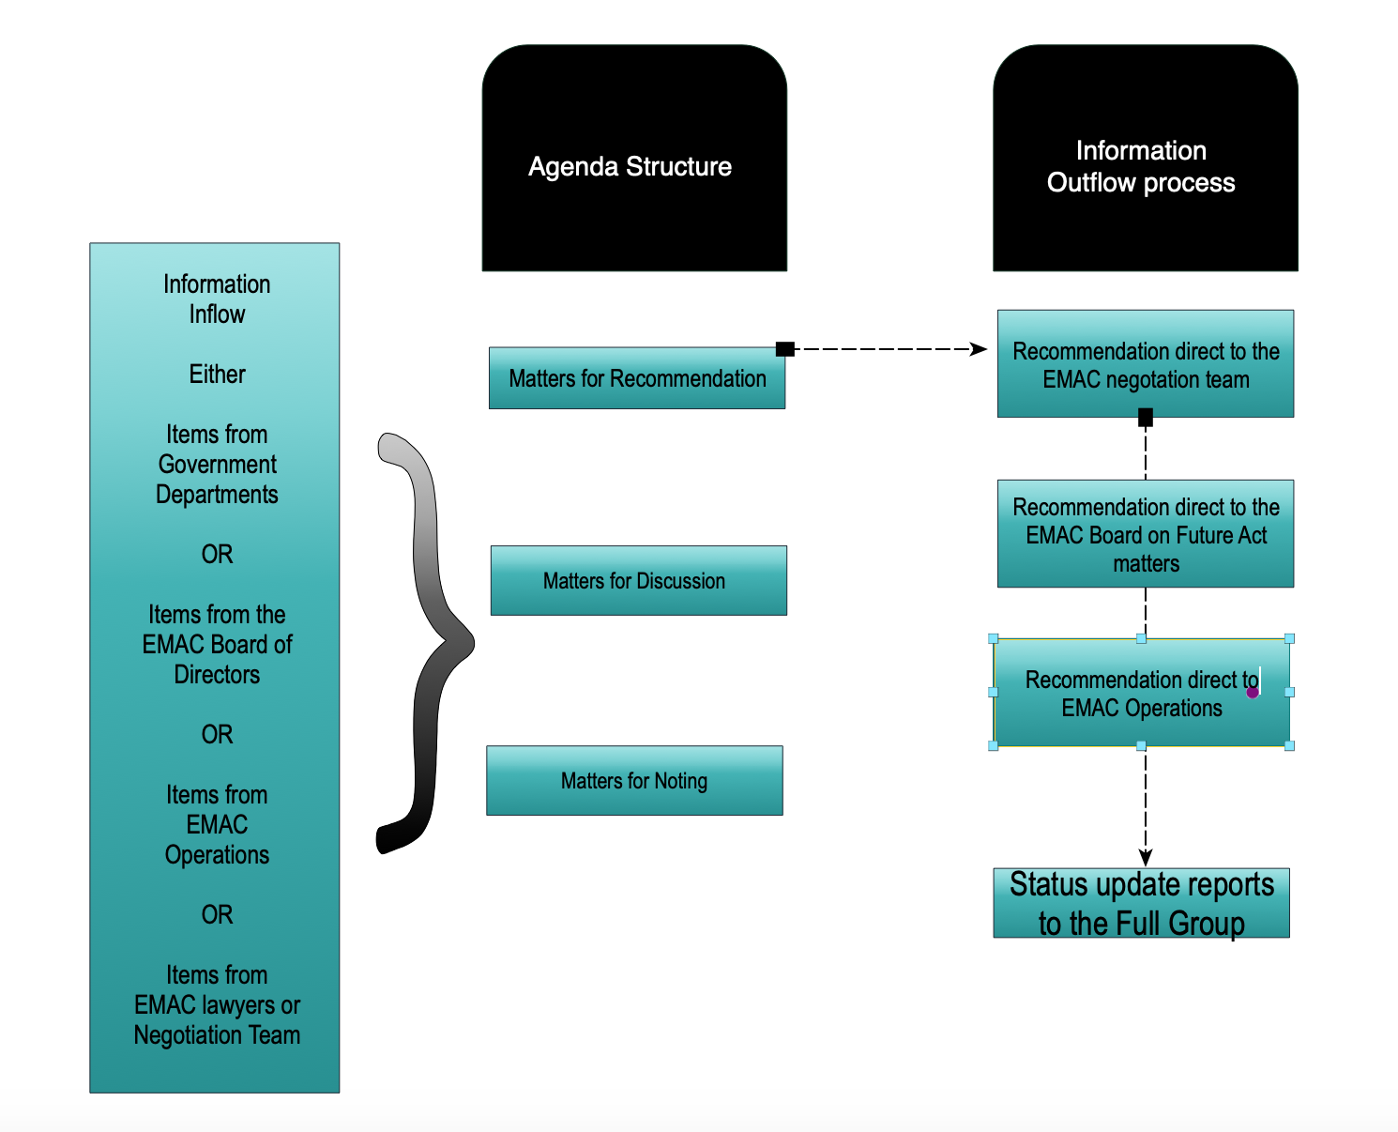

- Information via papers will inflow into the Subcommittee either via
    - Government Departments
    - EMAC operations
    - EMAC Board of Directors
    - EMAC Lawyers or Negotation Team
- Information is then reviewed via the Chair/s and secretariat and then arranged as necessary into the following catogories:
- Matters for Recommendation
2.) Matters for Discussion
3.) Matters for Noting
- The information will then be inserted into the agenda template (example provided below at Page 7 )
- The meeting would then proceed and be conducted sequentially following the agenda
- Recommendations agreed on will be forwarded onto to either:
    - Direct to the EMAC negotations team
    - Direct to the EMAC Board of Directors
    - Direct to the EMAC operations
- Work of the subcommittee will be provided in status updates to the EMAC Board and Full Group members

Frequency of Subcommittee meetings
The subcommittee shall meet at least three times a year at appropriate intervals in the financial reporting and audit cycle particularly in schedule with negotiation team meetings with the State of Victoria and otherwise as required. Special meetings may be convened as required. Should the Chair be unable to attend a meeting, the Chair may request that another member chair the meeting, or the meeting may be postponed.
Any urgent item that cannot wait until the next committee meeting, or is for information only, can be circulated out of session by the Chair. All Members will have the opportunity to respond to the out of session paper, recommending, noting or otherwise indicating their position on the paper. These responses will be the record of members views until the next committee meeting, at which time the collective direction and advice will be endorsed and minuted.

Quorum
A quorum of the Subcommittee shall consist of the Chair, or acting Chair, and 4 members. Should a quorum not be achieved, members may choose to hold the meeting, with any advice made not being considered final until the next meeting with a quorum, at which time the advice and recommendations can be endorsed and minuted.

Recommendation making and referral
Recommendations during meetings, wherever possible, are to be made by consensus or by clear majority. Recommendations are to be forwarded to the agreed appropriate avenue i.e. Board of Directors or negotiation team.

Chairperson
The chairperson shall be appointed for a 12-month duration (mid-January to Mid-December)
The Chairperson will be a current sitting Board member.
The EMAC Board of Directors will appoint a sitting Board member to role of subcommittee chair by way of resolution and will be appointed for a one-year term.

Secretariat
The role of the Secretariat is to provide for the smooth operation of Subcommittee proceedings, as well as ensuring that Members are fully informed and prepared. To fulfil this role, the Secretariat will be responsible for:
- managing the meeting schedule and preparing the agenda, in consultation with Members,
- compiling supporting papers, and ensuring their timely distribution
- arranging for staff and advisers to provide advice, and if required, to attend meetings of the Subcommittee to present this advice
- arranging for guest speaker invitees to attend and present when required
- recording attendance and apologies for each meeting
- taking the minutes of meetings, including preparation of the minutes, circulation of the draft for comment, and finalisation of the minutes in consultation with the Chair
- with the Chair, ensuring that committee actions, owners and timelines are identified in minutes, and are followed up and communicated appropriately
- circulating minutes of meetings.

Agenda and papers
Agenda items may be submitted by Subcommittee members or formally through the EMAC Board, following consultation with the Subcommittee secretariat. To be accepted for inclusion on the agenda, items must be within the authority of the Subcommittee.
Subcommittee papers should be submitted to the Secretariat and Chair for review approximately five days prior to the meeting. The agenda and supporting papers should be delivered to Members at least three working days in advance of each meeting. No papers are to be submitted to the committee on the day of the meeting unless by prior agreement with the Chair.
Confidentiality protocols may apply for selected items. Papers marked ‘confidential’ are not to be circulated beyond the Subcommittee membership.
Agendas will be set out as follows:
AGENDA
Date, Location and Time.
ITEM |  | Papers | Information Outflow
1 | OPEN
1.1 | Welcome and apologies | No
1.2 | Disclosure of conflicts of interest | No
1.3 | Minutes of previous meeting: | Yes
2 | MATTERS FOR RECOMMENDATION
2.1 | XXXXXXX | Yes
2.2 | XXXXXXX | Yes
2.3 | XXXXXXX | Yes
3 | MATTERS FOR DISCUSSION
3.1 | XXXXXXX | No
4 | MATTERS FOR NOTING
4.1 | XXXXXXX | Yes
4.2 | XXXXXXX | Yes
5 | OUT OF SESSION
 | Nil
6 | OTHER BUSINESS
6.1 | XXXXXXX | Yes
6.2 | Next meeting
 | Close meeting

Minutes
The proceedings and recommendations of all meetings will be minuted to reflect key outcomes/actions and will be provided to members following each meeting. The minutes will be circulated excluding confidential items the members in consultation with the Board determine to be confidential/in camera.

Responsibilities and behaviours
Overarching statement on Lateral Violence
The Subcommittee is a culturally safe and secure environment where members feel safe and draw strength in their identity, culture, and community. The Subcommittee will not tolerate lateral violence in any form (Lateral Violence undermines and attacks identity, culture, and community).

Members
Members will act in accordance with legal requirements, ethical standards, and relevant policies including conflict of interest and the relevant codes of conduct and values of EMAC.
The responsibilities and behaviours of Members are to:
- maintain a thorough understanding of, and comply with, the Terms of Reference including the code of conduct and the expectations of Members in meeting processes
- understand the strategic priorities and role of the EMAC, and act in the best interests of the organisation and service system
- prepare, provide feedback on, and submit materials and papers to progress the work of the Subcommittee as required
- embrace the solidarity principle that applies once a recommendation has been made, and demonstrate collective accountability and responsibility for the direction taken
- socialise feedback and outcomes of meetings with EMAC citizens as per the communication method agreed by the Subcommittee, including key messages and subsequent work that will be progressed by the Subcommittee
- demonstrate active listening and provide fellow Members with the opportunity to speak freely and ask questions
- ensure that a diverse range of views and perspectives are considered, and explicitly and respectfully engage, regardless of individual viewpoints.
- facilitate an environment to enable members to behave to the highest standards and provide appropriate ways to report and act on inappropriate behaviours.

Chairperson
In addition to the expectations of Members outlined above, the role of the Chair is to lead the Subcommittee to achieve its aims and execute its responsibilities in line with its Terms of Reference.
The responsibilities and behaviours of the Chair are to:
- understand the Subcommittees Terms of Reference and coordinate efforts to meet and uphold the Terms of Reference
- manage Subcommittee meetings, including:
    - work with the Subcommittee Secretariat to set the meeting schedule
    - call special meetings as/if required
    - work with the Secretariat to ensure appropriate preparation and consultation has been undertaken to inform the agenda and papers
    - facilitate Subcommittee meetings including keeping discussion on track, ensuring all Members have an opportunity to express their views, seeking consensus/agreement on issues requiring recommendation, announcing results, actions, and follow up to be taken by whom and by when, and to close meetings
- Sight, edit / amend minutes if required (prepared by the Subcommittee Secretariat) before circulation to Members and the Board
- ensure minutes are circulated to Members and the Board within two weeks of the meeting
- ensure confidential items are discussed in a safe manner, and are not included in the formal minutes
- induct new Members and make sure they are aware of the Subcommittee Terms of Reference
- facilitate the regular review of the performance of the Subcommittee and its Members (see below).

Subcommittee review
The Subcommittee Terms of Reference will be reviewed at the first meeting of each calendar year, and additionally as/if required throughout the year. Any appropriate amendments will be recommended and referred to the EMAC Board for approval.

Membership remuneration
The Negotiation Team members remuneration for participation at scheduled meetings are:
Position | Attendance remuneration | Travel
All members/Directors (EMAC Board & elected EMAC citizen/s) | $200.00 | 0.73^{c} per/km
EMAC employees | $0.00, expectation of employment with EMAC | $0.00, expected use of EMAC pool cars.

